**Lab Assignment #2**

GitHub link: <https://github.com/ItsYourFriendFred/c304Lab2/tree/master>

Screenshots:

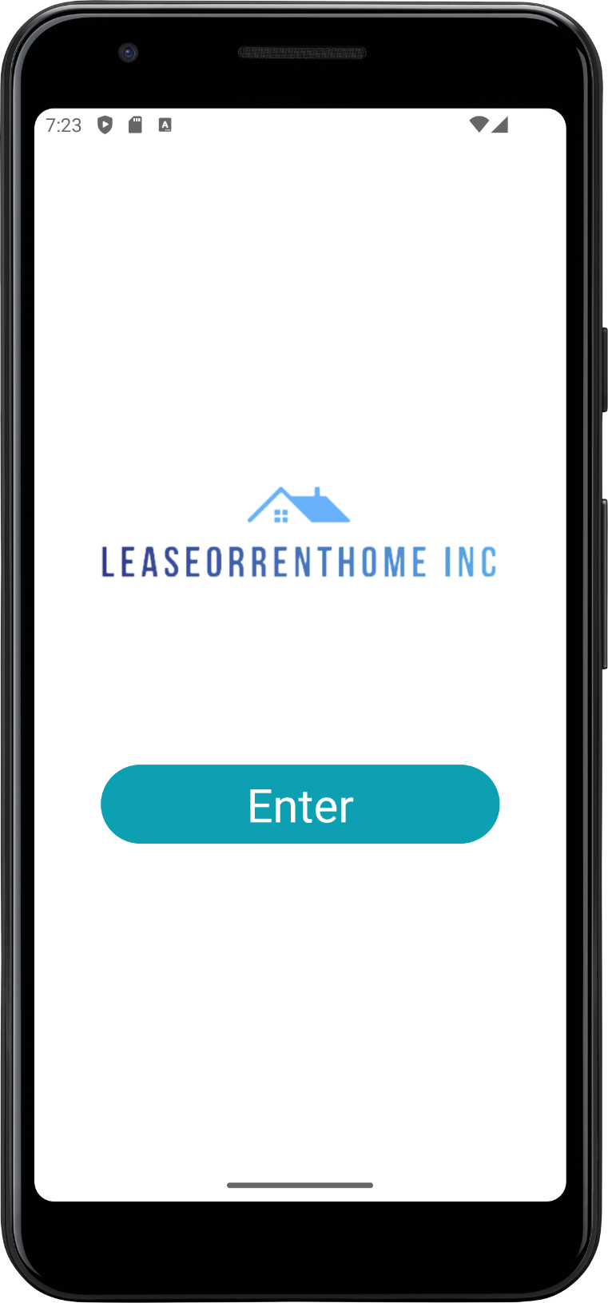

Figure 1. Home Screen

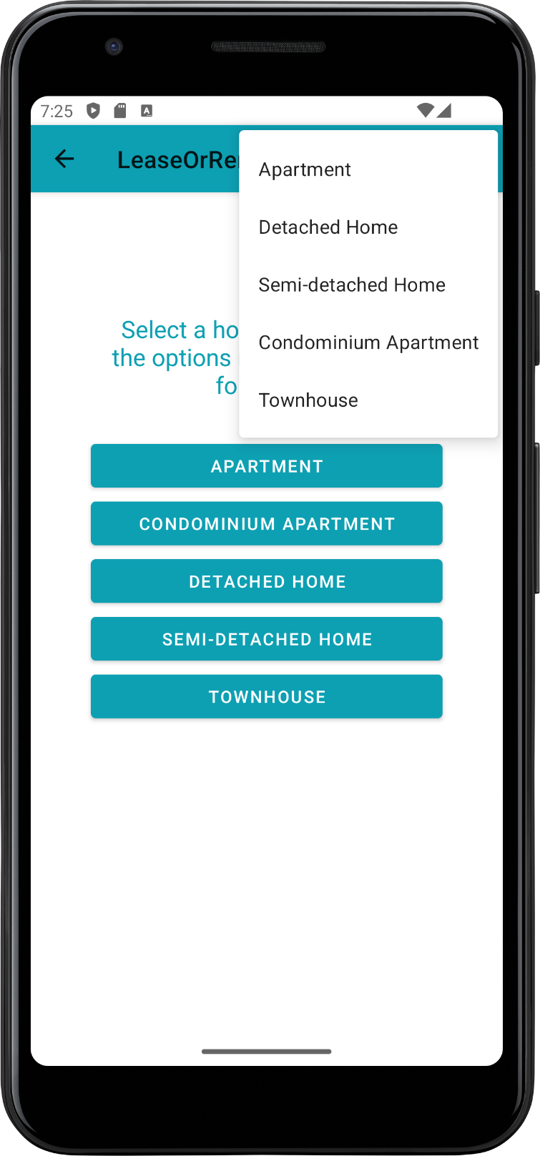

Figure 2. Second Screen. Showing options menu and buttons to navigate to each housing type activity

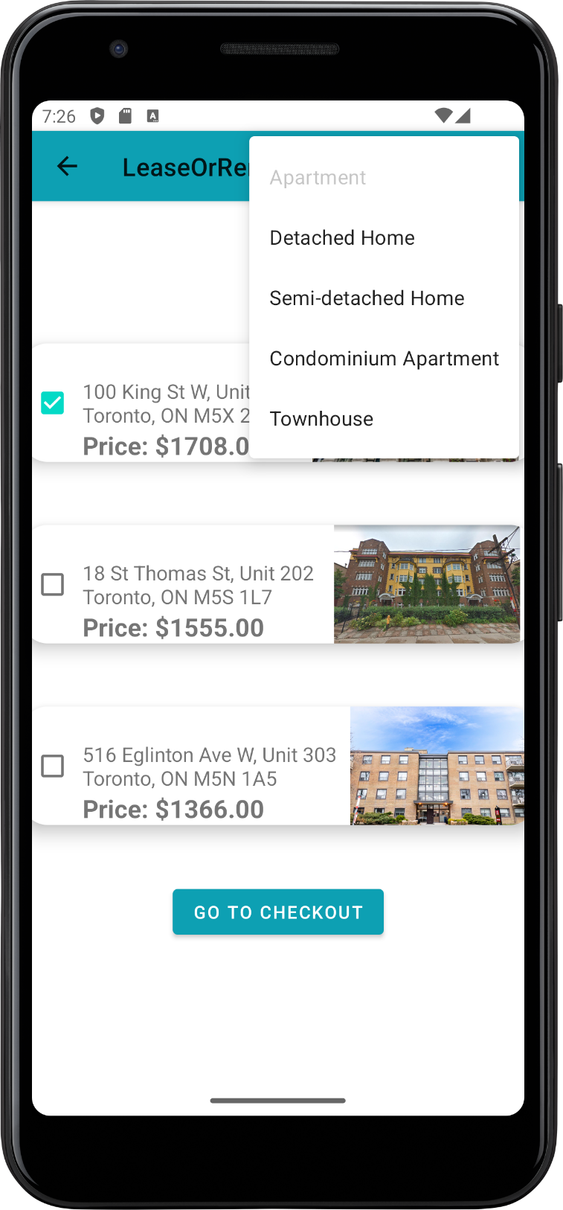

Figure 3. Apartment Activity

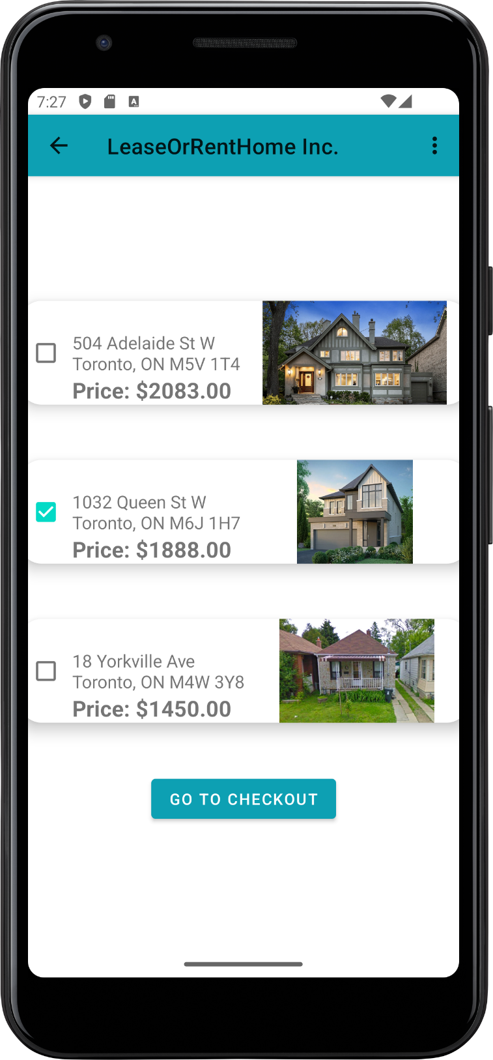

Figure 4. Detached Home Activity

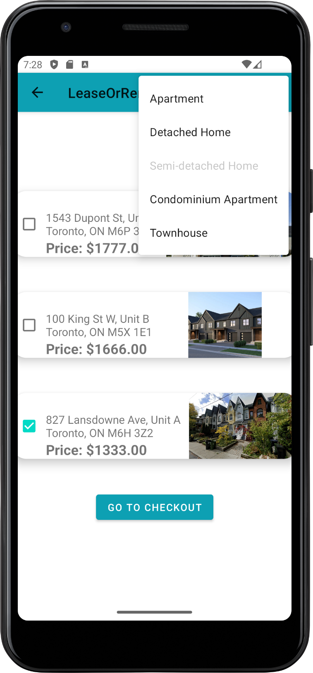

Figure 5. Semi-detached Home Activity

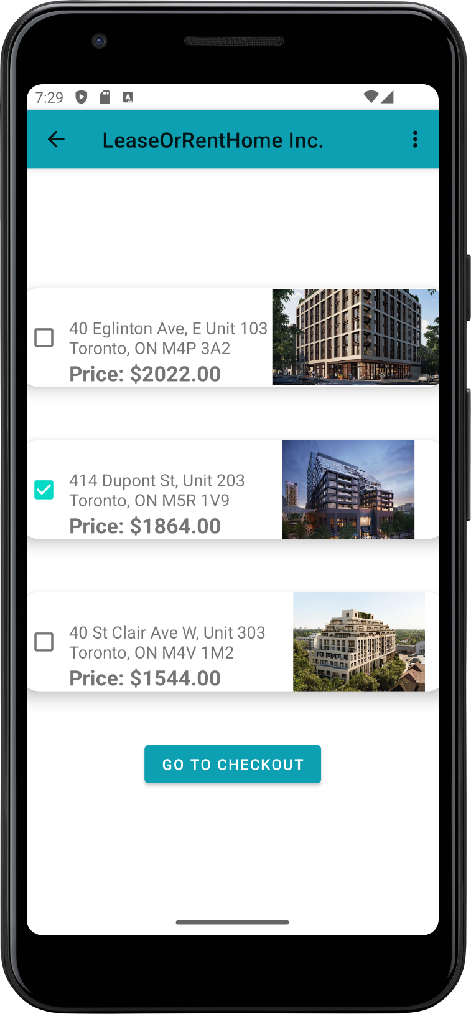

Figure 6. Condo Activity

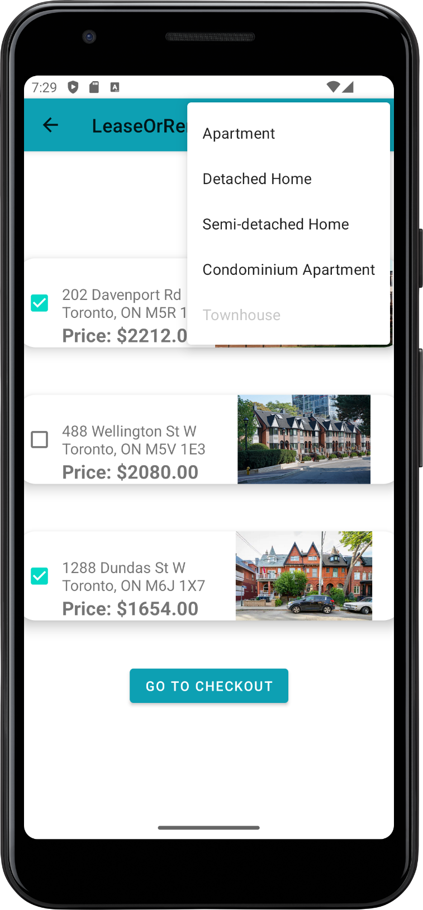

Figure 7. Townhouse Activity

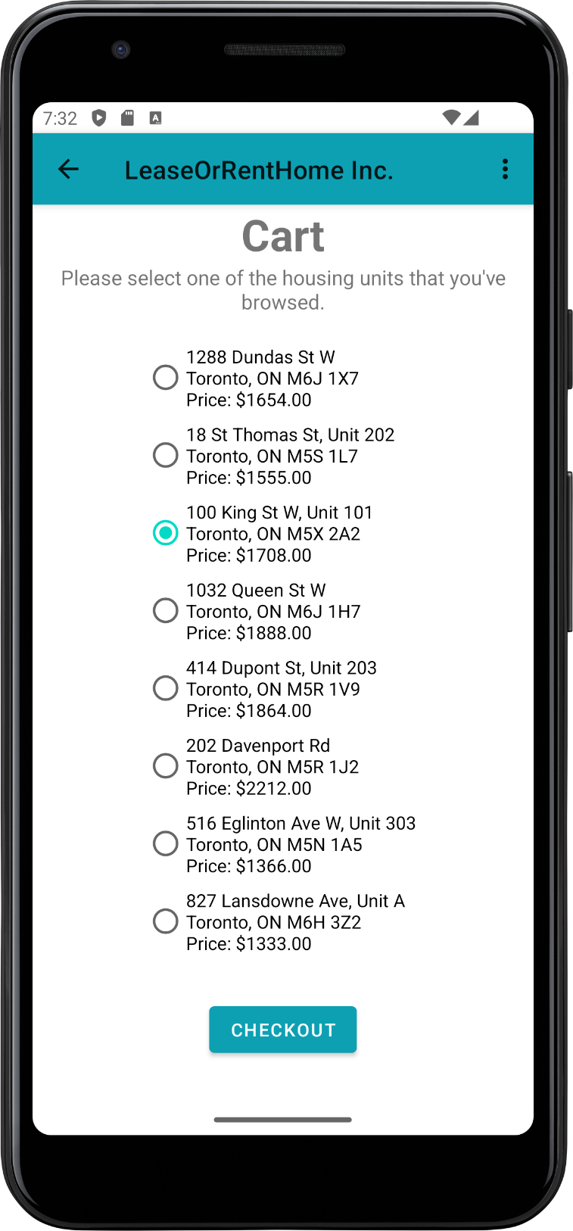

Figure 8. Checkout Screen

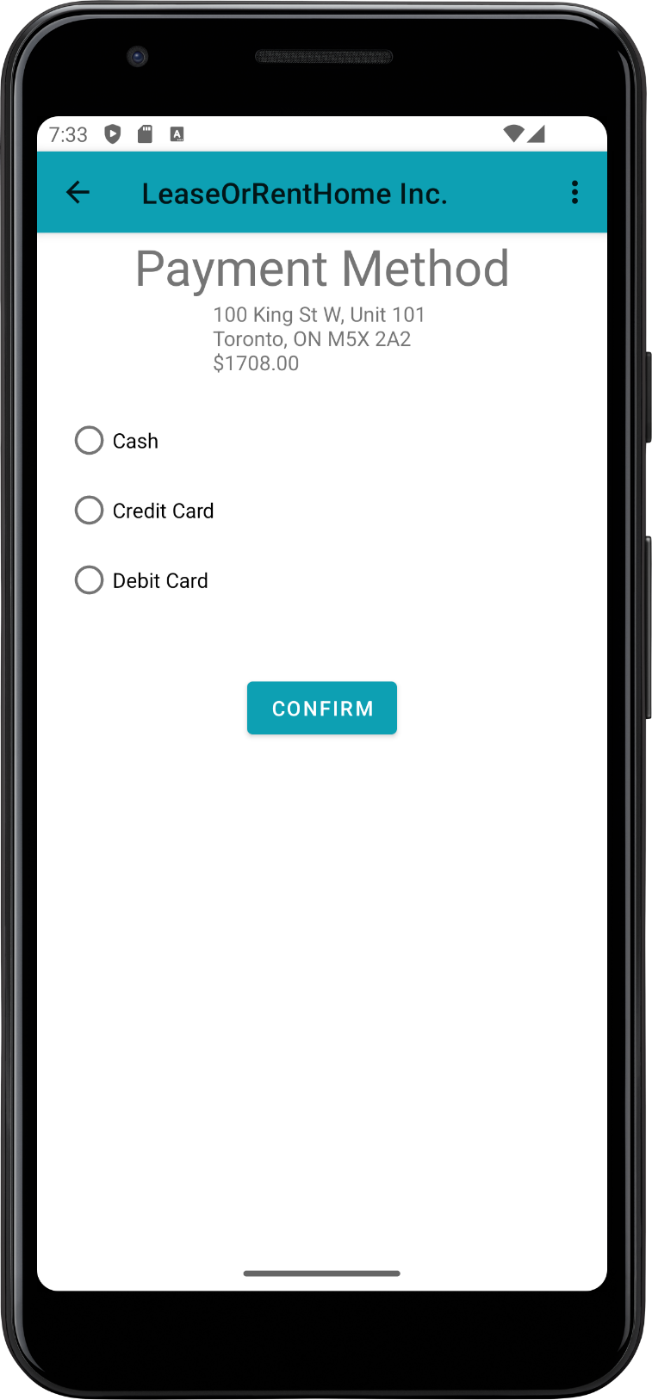

Figure 9. Payment Screen after checkout screen

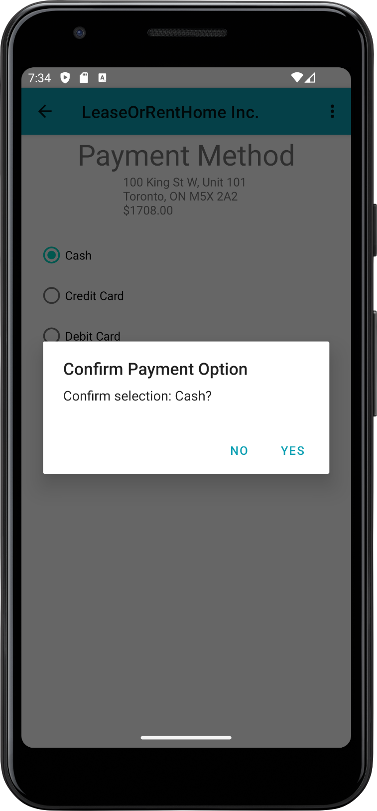

Figure 10. Showing confirmation modal/dialog when selecting and then submitting a payment option

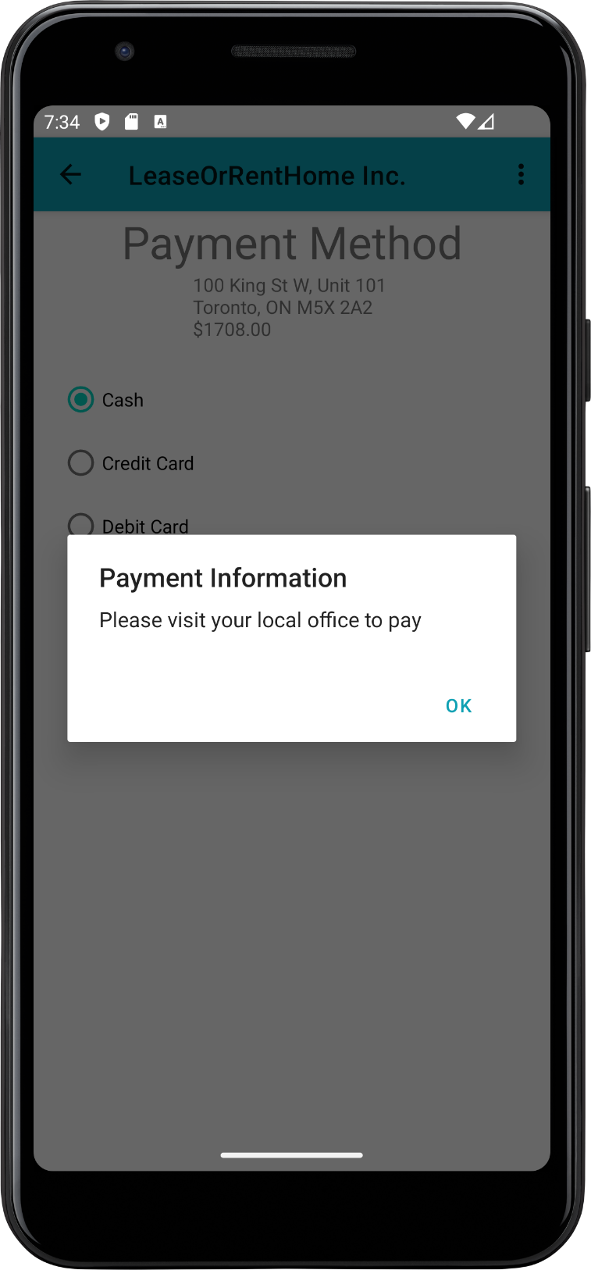

Figure 11. Information modal/dialog after confirming Cash payment.

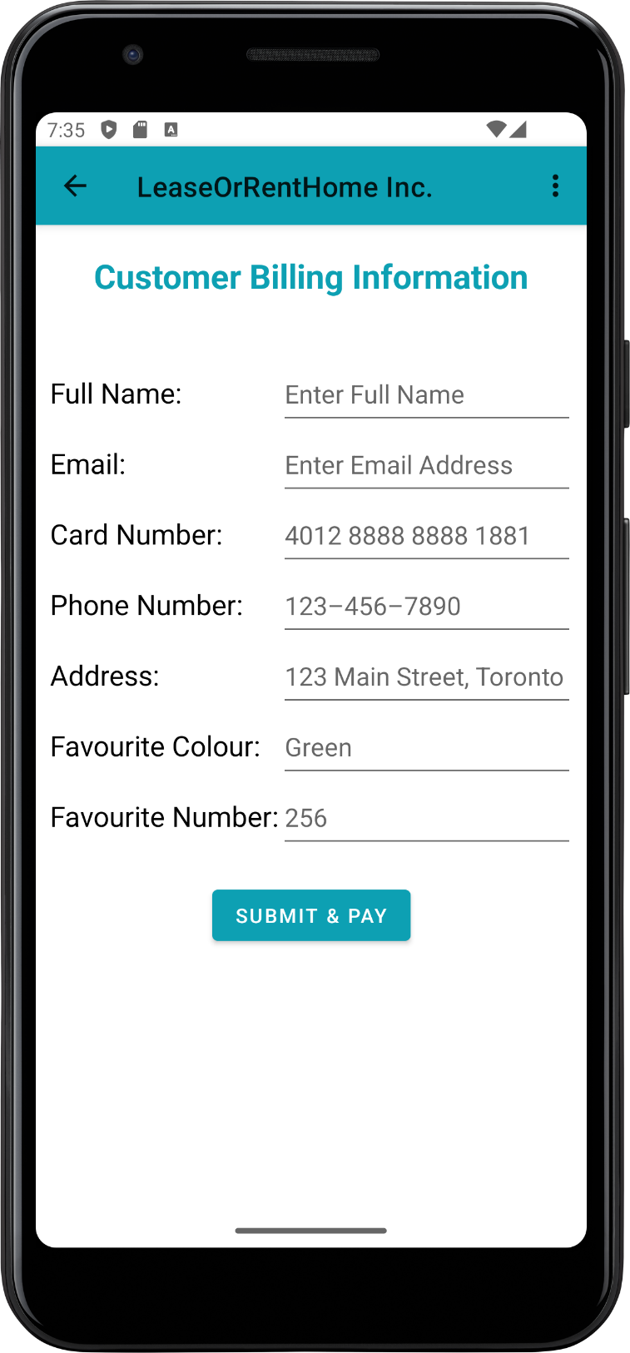

Figure 12. Customer Information Screen. Both credit card and debit card options will take you to this screen.

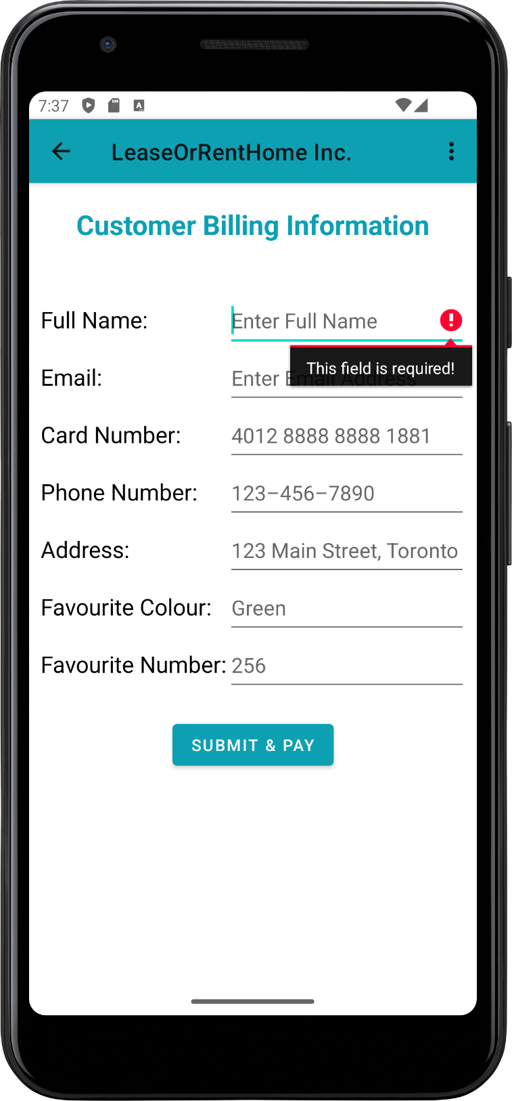

Figure 13. Full name validation. Checks length only.

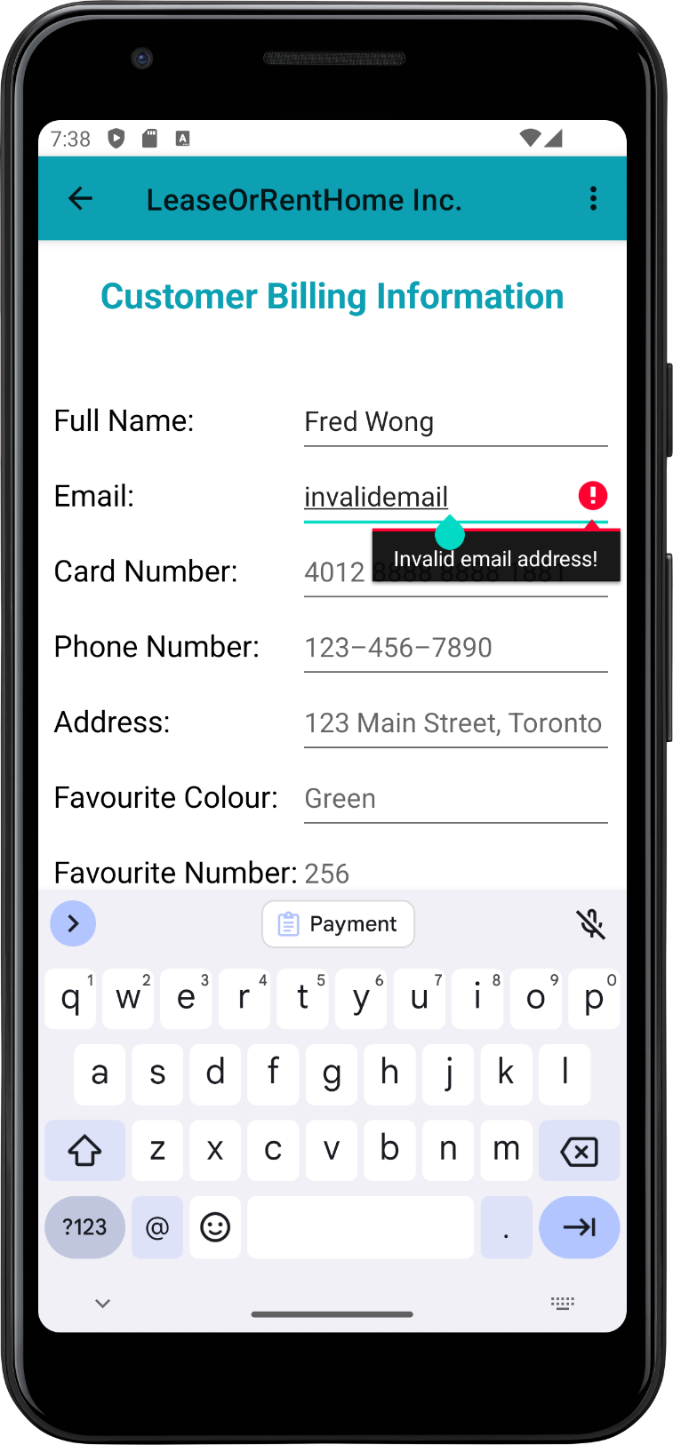

Figure 14. Email validation. Checks formatting (username, @ symbol, and domain name).

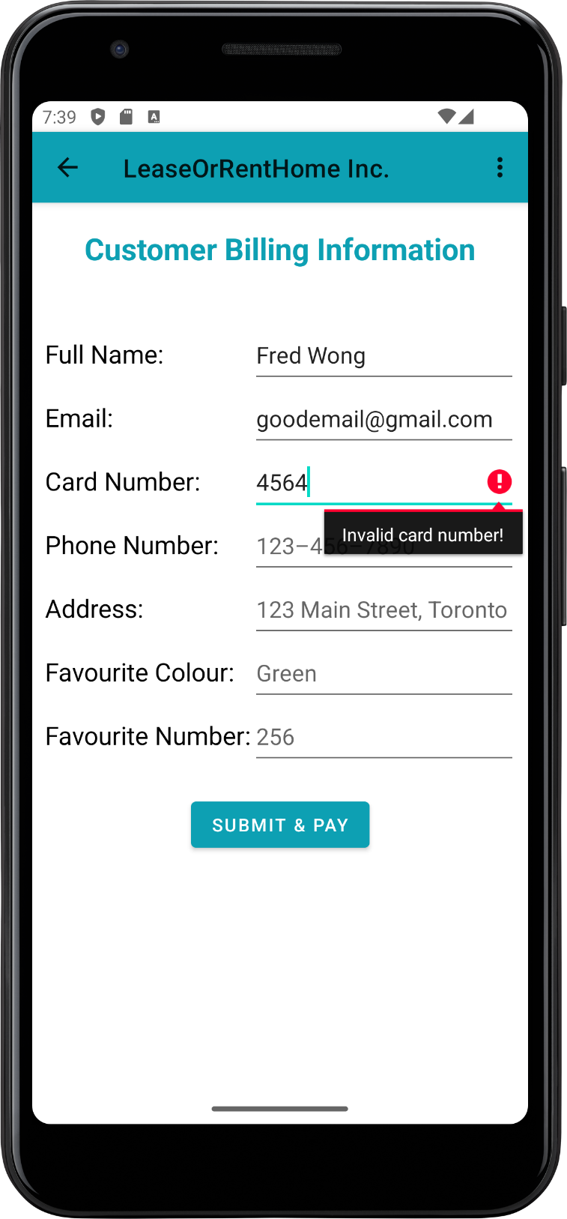

Figure 15. Card number validation. Checks length only. Ignores whitespaces.

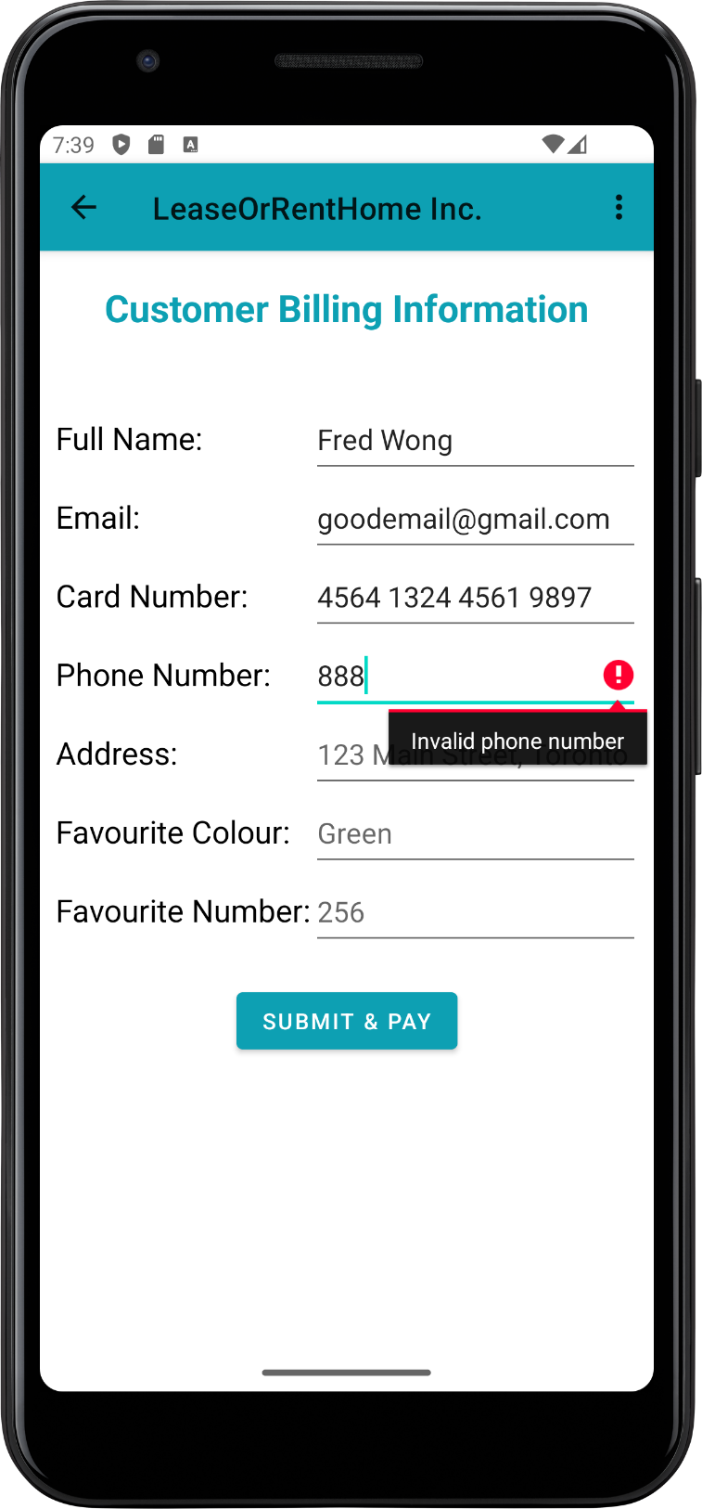

Figure 16. Phone number validation. Checks for length; input is restricted to just numbers for user simplicity.

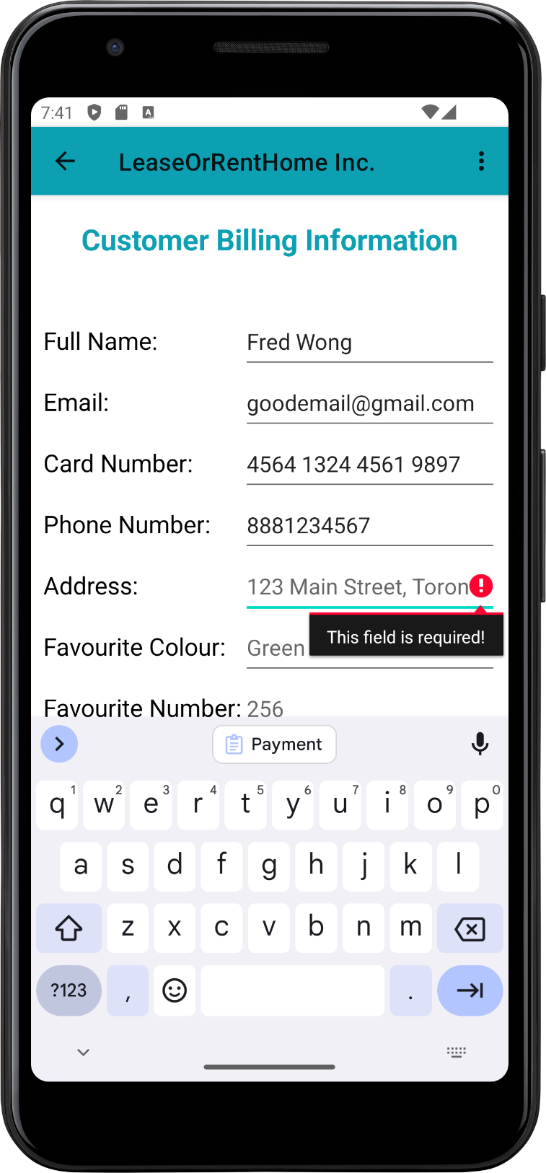

Figure 17. Validation for address. Only needs to be not empty for simplicity.

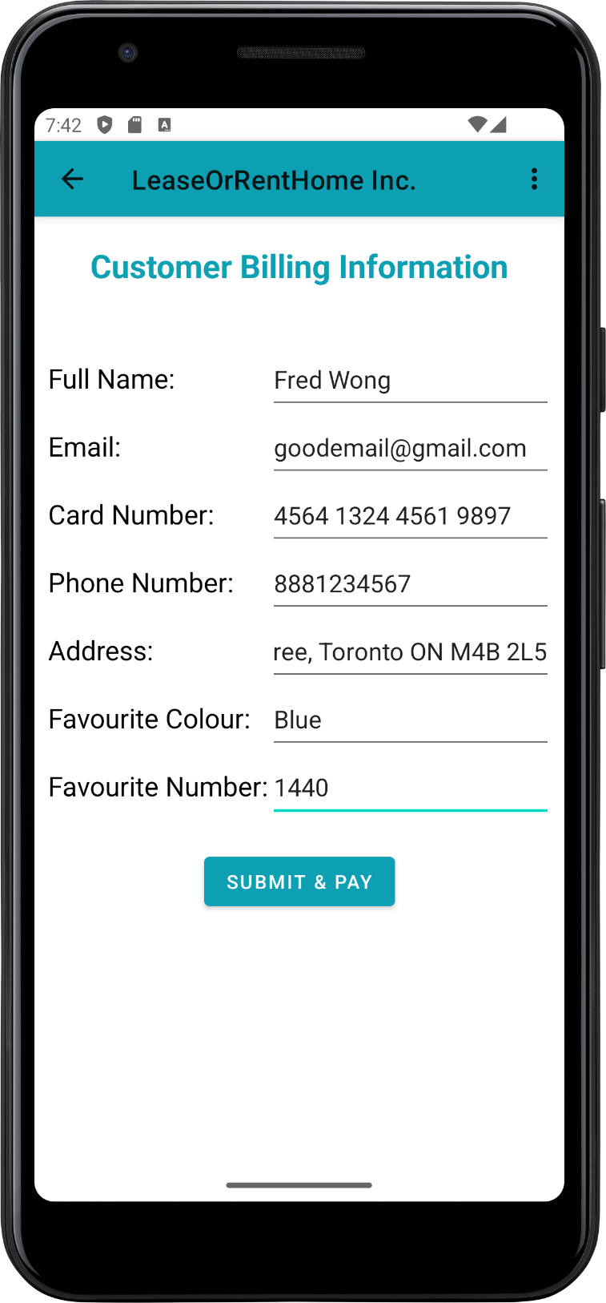

Figure 18. Complete form with no validation errors

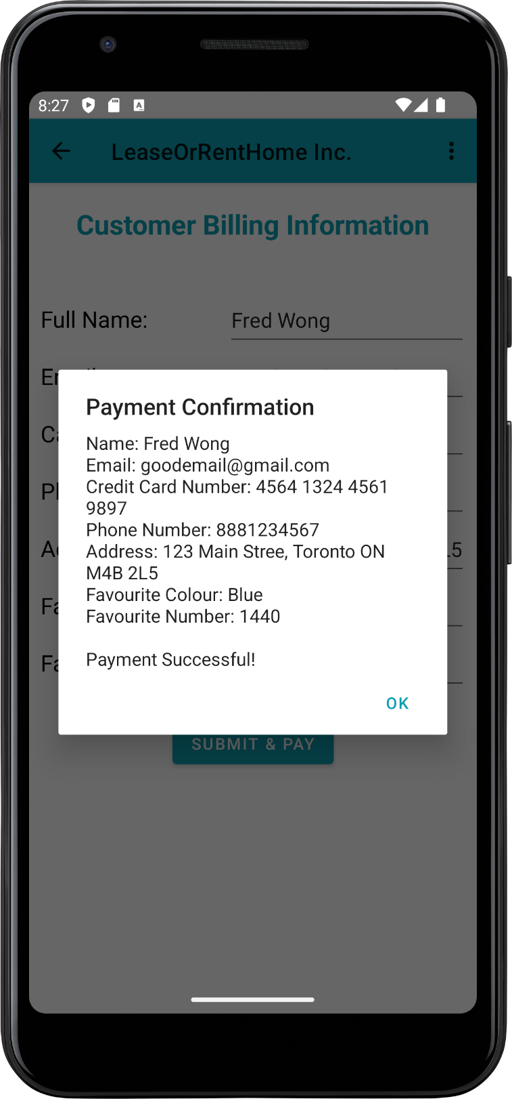

Figure 19. Information modal/dialog after completing form with all valid fields and submitting. Card Number shows Credit or Debit based on payment selection.

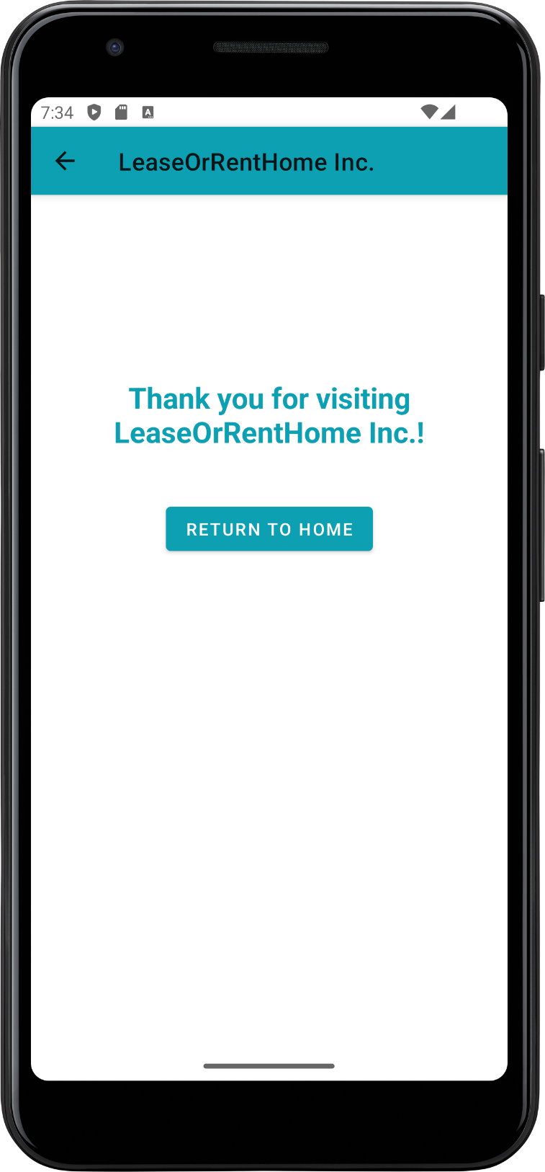

Figure 20. Exit screen after finishing any payment option.